Fall Special Trimester, 2025
OT 609
Personal Transformation IV

SYLLABUS AND TOPICAL OUTLINE

 | Instructor Information
Faculty | Jaimee MB Hegge, OTD, OTR/L, CKTP, HEAS, Level 1 Functional Pelvic Health Practitioner (course coordinator)
Contact | 203-371-7734 (Jaimee’s office)
Office Hours | Individual course instructors by appointment
Office Location | N124 (Jaimee)

Course Overview
 | Course Information
Course Meeting Times | Asynchronous, individual and group advisements meetings directed by course instructor
Format | Online with individual and group advising
Location | Building location: CHE, 4000 Park Avenue, Fairfield, CT
Credit & Workload | This course is offered in a 16-week trimester calendar. One (1) credit hour represents 45 hours of work over the course of a term, which includes activities such as lectures, discussions, group work, individual work, and experiential activities
Prerequisites | Successful completion of Personal Transformation 3

Course Information
COURSE DESCRIPTION and PURPOSE: Personal transformation IV is a continuation of the course you began in your first trimester. This course will again require self-reflection and will begin to relate your self-reflection to the practice of occupational therapy. This course in the series will also help prepare you for employment as you will create a resume, write a personal mission statement, and consider important factors of employment and your values in relation to job opportunities. We believe that the process of becoming an occupational therapist in this program will transform you. You will document your transformation in your portfolio and will create a professional development plan to guide your continued growth during your first year out of school.

COURSE RELATIONSHIP TO OCCUPATIONAL THERAPY PRACTICE AND AOTA VISION 2030:
“Vision 2030 is:
- The guiding force and definitive aspiration for the profession, to which AOTA aligns its organizational, strategic, and operational plans for maximum mission impact over the next five years.
- Inextricably linked to AOTA’s mission to advance occupational therapy practice, education, and research through standard setting and advocacy on behalf of its members, the profession, and the public.
- Essential to the profession’s ongoing viability and success,” (AOTA, 2025).

“As an inclusive profession, occupational therapy maximizes health, well-being, and quality of life for all people, populations, and communities through effective solutions that facilitate participation in everyday living,”(AOTA, 2025).
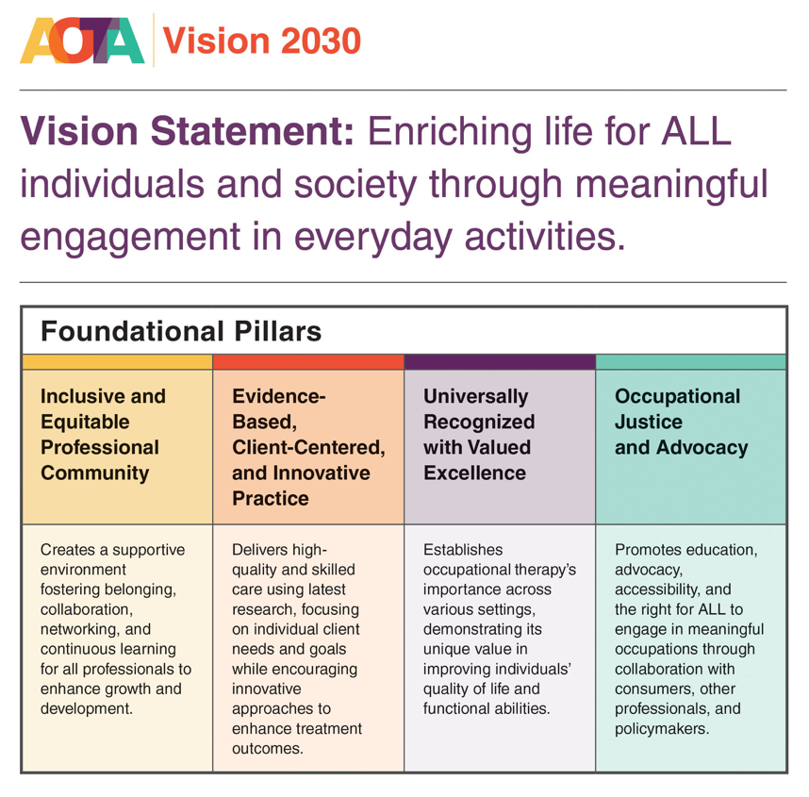(AOTA, 2025)

OUR THOUGHTS ABOUT LEARNING IN RELATION TO THIS COURSE
While it may appear that knowledge is certain, that there are facts we can count on, in
reality knowledge changes over time. What we did in occupational therapy in the 1950’s is not what we do today. We can teach you skills, assessment tools, and specific
diagnostic categories, but all of that may be different in 20 years. That tool may no
longer exist, the DSM may change the criteria for a diagnosis or drop it altogether, and
the skills you rely on today may be shown to be ineffective by tomorrow's research.
Therefore, an important characteristic for you to develop is your capacity for curiosity
and the desire to continually learn and improve. If you remain static in OT, you may
become bored and may burn out. If the profession remains static, we may become
irrelevant. All of us must engage in continual improvement for our profession to remain
viable and for us to achieve our centennial vision.
We believe that all our students can learn given sufficient resources,
proper instruction, and adequate motivation and effort. For you to continue a path
of lifelong learning as an OT, and not become stifled and complacent, you will need the
intention to do so, the motivation, drive, and curiosity to ensure you do not become
bored or boring, in your practice. We will make this course playful and silly wherever it
is appropriate to do so.
We also believe in evidence-based teaching and have crafted activities and
assignments that research suggests will help you learn the material. There is
abundant evidence that repetition is important, that writing (in pencil) helps you to remember, that merely reading and highlighting content is not sufficient for long term
earning, and that quizzes, and self-questioning will help you learn. We will use many, if
not all, of these strategies this trimester.
RELATIONSHIP TO CURRICULUM DESIGN: The Sacred Heart University occupational therapy program curriculum-design is based on the longstanding symbol of occupational therapy, the profession, going back to our professional history and roots, to that of weaving. Weaving is the craft of fabric production, in which two distinct sets of yarns or threads are interlaced at right angles to form a fabric or cloth. The visual representation of a piece of cloth shows the intersections of the warp and weft of the woven fabric. Our curriculum design utilizes the warp as a representation of the values of the profession, the program, and the university. Within this course, the values of authenticity, justice, integrity, altruism, and open-mindedness are emphasized. The weft are the threads or streams of occupational therapy content, knowledge, skills, the experiences that comprise the foundation of our program (occupational performance analysis and interpretation, enabling occupations, scholarship, professional communication, interpersonal skills, and professionalism).

INSTRUCTIONAL METHODS: This course will be completed through a variety of online activities, self-assessments, and both individual and group advising. Students will continue adding to their portfolio to document their transformation throughout the course of the program.

COURSE POLICIES: All university programs and courses adhere fully to the University Policy on Academic Integrity, as stated in the Undergraduate and Graduate Catalogs and on the Academic Integrity Web Page. Academic dishonesty (e.g., cheating, plagiarism, and other unethical behavior) could result in a grade of F for the assignment and/or course.

This syllabus and course outline are subject to change by the instructor during the trimester. Changes may be necessary because of students’ specific interest(s), general class progression, and class cancellations. If such changes are implemented, they will be announced in class and posted online. This syllabus and any addendums attached shall not be construed by the student as a contract, implied or expressed, between the student and/or the professor and the University.

COURSE MATERIALS:
REQUIRED TEXTS: None

RECOMMENDED TEXTS:
Davis, L. & Rosee, M. (2015). Occupational therapy Student to Clinician: Making the transition. Thorofare, NJ: Slack
Nagayda, J., Schindehette, S., & Richardson, J. (2005). The professional portfolio in occupational therapy: Career development and continuing competence. Thorofare, NJ: Slack
Link to SHU Bookstore: SHU Bookstore

STUDENT BUDGET FOR COURSE SUPPLIES: All materials for this course will be provided by your instructors. The Occupational Therapy Department has already selected and purchased a wide range of materials for use during this course. If, for any reason, you choose to engage and teach an activity for which we do not have the specific materials, you may have to purchase those materials from your own funds. Adjust as needed for your course

INDIVIDUAL AND GROUP WORK: Students are responsible for independent reading of all materials. Students are responsible for independent work, unless there is a requirement for group work. If group work is a requirement, students are expected to participate fully, collaborate, share, and exchange in equal measure.

LEARNING OBJECTIVES AND OUTCOMES: Each program in OT must meet the same Accreditation Council for Occupational Therapy Education (ACOTE) standards. How they are met varies from program to program. The standards that are addressed in this course are listed in the table below. This link will allow you to review all of the ACOTE standards: NBCOT website.

The course objectives, program objectives, the mission and vision of the department and the overall curricular design are all linked to the ACOTE standards. Table 1 shows the connection between the entire course series objectives, the program objectives they are linked to, and the ACOTE standards that are addressed in this course, as well as how we plan to meet and measure the learning objectives for this course.

Table 1- Program Outcomes, Course Objectives, ACOTE Standards, Learning Activities & Measures
Program Outcomes | Course Objective | ACOTE Standard | Learning Activities | Learning Measures
Engage in continual learning and evidence-based practice with intellectual open-mindedness  Apply ethical reasoning aligned with the AOTA and the program’s values to make decisions and practice professionally | Engage in self-reflection to guide continued learning and transformation. | B.2.9 Personal and Professional Responsibilities  Create and implement a plan to address individualized personal and professional responsibilities that are consistent with current accepted standards and long-term professional goals.  The plan must address the following:  • Personal well-being.  • Alignment with current accepted norms in occupational therapy practice.  • Advocacy related to clients, occupational therapy, or the role of the occupational therapist or occupational therapy assistant. • Long-term career objectives.  • A strategy to evaluate, refine, and update the plan over time. | Online activities  Self- assessment  Advising meetings | Portfolio  Professional Development Plan  Retake Self-assessment scales
Demonstrate leadership through scholarship and professional service  Apply ethical reasoning aligned with the AOTA and the program’s values to make decisions and practice professionally | Evaluate your own academic and professional performance. | B.2.9 Personal and Professional Responsibilities  Create and implement a plan to address individualized personal and professional responsibilities that are consistent with current accepted standards and long-term professional goals.  The plan must address the following:  • Personal well-being.  • Alignment with current accepted norms in occupational therapy practice.  • Advocacy related to clients, occupational therapy, or the role of the occupational therapist or occupational therapy assistant. • Long-term career objectives.  • A strategy to evaluate, refine, and update the plan over time. | Online activities  Self- assessment | Portfolio  Vision 2025 Plan Update and Self-Reflection paper
Demonstrate leadership through scholarship and professional service  Apply ethical reasoning aligned with the AOTA and the program’s values to make decisions and practice professionally | Organize a portfolio that documents your professional competence and growth and supports your evaluation of your own professionalism and professional involvement. | B.4.5 Requirements for Credentialing and Licensure  Demonstrate knowledge of applicable national requirements for credentialing and requirements for licensure, certification, or registration consistent with federal and state laws | Online activities  Self- assessment  Advising meetings | Portfolio  Professional Development Plan  Vision 2025 Plan Update and Self-Reflection Paper

Topical Outline & Course Schedule:

Subject to change per instructor

Table 2: Topical Outline
Week | Readings | Content | Assignments | Assessment Strategies
1 - 2 | None required | You will redo specific self-assessments that you completed in the first trimester as partial measure of your transformation throughout this program. | Self-Assessments due the end of week 2 | Retake GRIT scale, Self-Efficacy Scale (posted to BB), and VARK questionnaire.
3 - 5 | Readings posted to BB | Professional Development Plans  Continuing education, CEUs/ PDUs/ NBCOT and State requirements, Licensure, Essential functions | Group Advisement meeting during week 3 or 4 | Advisement Attendance Rubric Posted to BB  Ungraded (optional) Linked In Post – CEU Course identification
6 - 8 | Readings Posted to BB | Leadership opportunities in state OT associations and AOTA | Submit Vision 2025 plan with updates on goal areas Due October 5th at 11:59PM  Individual advising meeting to discuss your individual Professional development plan during week 6 | Graded as Complete or Incomplete  Advisement Attendance Rubric Posted to BB
9 - 11 | Readings posted to BB | Mentoring in OT- importance and process  Career Services at SHU | Professional Development Plan Due by November 2nd at 11:59PM  Be working on your final portfolio | PDP Rubric Posted to BB
12 - 13 | None | Continue building your final portfolio | Final Portfolio Due by November 23rd at 11:59PM  Final Group Advisement Meeting | Portfolio Rubric posted to BB  Advisement Attendance Rubric Posted to BB
14 - 15 | None | Reflect on all assignments in Personal Transformation 1-4 and complete your final Self-Reflection paper. | Final Self-Reflection Paper Due by November 30th at 11:59PM | Self-Reflection Paper Rubric posted to BB

Final Grades

Please read this section carefully. Final grades will be determined by student performance according to the following:

Assignment/Assessment | Percentage of Grade
Portfolio  Students will finish their online portfolio to document self-transformation. Methods for grading the final portfolio will be provided on BB. However, ½ of the grade will come from faculty and the other ½ will be self-evaluation. | 30 %
Submit Updated Vision 2025 Plan  Submit this to the blackboard with updates on your progress during the past year. | 5 %
Retake Self-Assessments from Fall 2024  You will redo specific self-assessments that you completed in the first trimester as a partial measure of your transformation throughout this program. These include: GRIT scale, Self-Efficacy Scale, and VARK questionnaire. | 5 %
Final Self-Reflection paper  This reflection paper is an opportunity to evaluate your growth, document your readiness for clinical practice, and set goals for continued professional development. You will provide evidence of your competence, professional behaviors, and critical thinking, and include peer feedback. | 15 %
Professional Development Plan  Using the AOTA’s Professional Development Tool (PDT) as a guide, you will complete the process of self-assessment and create your first professional development plan. It will be submitted to BB and also will be put into your portfolio. It is a one-page description of your goals for your first year of practice. | 10 %
Professional Behaviors  Students will be required to demonstrate professional behaviors. Difficulties with professional behaviors may result in additional advising, loss of points, the development of a professional behavior plan, or other activities designated by the professional performance committee. | 30 %
Attendance at advising meetings  Students will have 2-3 advising meetings across the trimester, either in a small group or as an individual. | 5%
Total | 100 %

The final letter grade is assigned in accordance with the university grading policy: SHU Graduate Grading System.

Student Expectations
ATTENDANCE: As per program policy, a 100% attendance rate for all courses is required. Per university policy, attendance will be recorded on Blackboard for each class and for each student. Absences from classes are allowed only under extraordinary circumstances, such as illnesses, emergencies, religious obligations, or important family events; for example, a wedding of an immediate family member. Documentation for an absence due to an important family event requires at least three weeks advance notice, and documentation of all other absences confirming circumstances that caused them are required within a week of returning to school. Please contact the course instructor in advance of an absence unless it is an emergency. In case of emergency, notify the department as soon as possible.

Failure to follow these procedures will result in the total grade reduction of one letter grade increment for each unexcused absence. Please refer to COVID Contingencies policy in the Student Manual with regards to absences/isolation for colds and flu symptoms, or the SHU Coronavirus web page. Please note that, while classes might take place online (using Zoom, Webex, or Microsoft Teams) in case of inclement weather or other unforeseen circumstances, attendance policies for the online classes are the same as for the in-person classes.

To the extent permitted by federal and state copyright laws, the class lectures and materials provided by the professor are copyrighted. By participating in the class lectures, students consent to the video and audio recording of said lectures. As part of the requirements of the course, students are required to participate, whether in person or via electronic communications. At the professor’s discretion, students may be required to leave their audio and video devices on during the class lectures.

ACADEMIC INTEGRITY and PARTICIPATION: Please refer to the 2025-2027 O.T. Student Handbook.

PROFESSIONAL BEHAVIORS: Please refer to the 2025-2027 O.T. Student Handbook.

ARTIFICIAL INTELLIGENCE PLATFORMS: In accordance with Sacred Heart University’s Academic Integrity Policy, the use of Artificial Intelligence platforms is on a case-by-case basis in the Department of Occupational Therapy. Students are permitted to use artificial intelligence chatbots (such as ChatGPT) only when explicitly directed by the instructor. If you are ever unsure whether the use of an artificial intelligence chatbot is allowed, please contact the instructor prior to using it.

How We Support Your Learning at SHU

WHAT YOU CAN EXPECT FROM YOUR OCCUPATIONAL THERPAY FACULTY:
- Your materials will always be available to you at least one week before class
(usually much earlier than that).
- We will answer your emails during the work week within 24 business hours.
- We will grade your papers and have things back to you within 3 weeks of your
turning them in (if you turn them in on time).
- We will explain why we are doing what we are doing. We don’t believe in ‘busy
work’ and won’t give you any.
- We will have very high standards for your behavior and ours. We believe in
Stephen Covey’s 7 habits of highly effective people. We also believe that to demonstrate and model responsibility and efficacy, we must have integrity. Integrity starts with making and keeping promises and commitments. We pride ourselves on being dependable and keeping our commitments.
- When we are meeting with you, and in class with you, you will have our
undivided attention. We will all practice ‘being present’ in the moment in our
communication with each other. ‘Being present’ in the moment is an important skill to learn. If it ever seems like we are distracted and not listening
fully, please say so. If you ask a question when we are distracted or when we
cannot give you our full attention (for example at the beginning of class while
setting up), we will tell you so and will tell you when we will be able to give you
our full attention.
- We will start and end class on time, unless there are extreme events.
- We spend a lot of time planning what we will do in class and what we think are
activities that will help you learn this material- but that will also be fun.
- We will model the same professional behaviors we expect of all of you. We will
treat you as a future colleague and an adult student. Please speak with us if you're having any difficulties with the material or assignments. However, we also
believe in personal responsibility.

UNIVERSITY STUDENT SUPPORTS
Our Commitment to Inclusive Excellence
As a student, it is important to know that at Sacred Heart University, inclusive excellence is not just a value – it is a foundational element that shapes our academic mission, our community culture, and our collective future. As a Catholic institution guided by a commitment to human dignity, justice, and the common good, we believe that true excellence is only possible when equity, inclusion, and belonging are fully woven into the fabric of our classrooms and university life.
In every course, we are called to foster environments where all members of our community feel seen, heard, respected, and empowered to thrive. This is a shared responsibility among SHU faculty, staff, and students. We look forward to the contributions you will make to help uphold this commitment to one another University Student Offices
There are multiple support offices eager to support your learning and success at SHU. The services below are available for undergraduate and graduate students:
Academic & Technology Supports:
- Center for Teaching and Learning (CTL) - offers tutoring, writing, and learning support for all SHU undergraduate and graduate students. Visit the PASS Portal to sign up for tutoring, submit a paper for feedback through the Online Writing Lab (OWL), or look up peer-assisted learning opportunities for specific courses. Questions? Contact CTLtutoring@sacredheart.edu.
- Office of Student Advising & Success (SAS) – offers appointments with student success coordinators and advisors who are ready and eager to meet with you about exploring majors and programs, and key academic skills such as time management. Questions? Contact studentsuccess@sacredheart.edu.
- Office of Student Accessibility (OSA) - Sacred Heart University provides equal educational opportunities for all students regardless of disability status. Students requesting accommodations should contact OSA. Students must be registered with OSA and submit appropriate documentation to be granted accommodations. · Questions? Contact Kathy Radziunas (radziunask@sacredheart.edu).
- Technical Support – offers technical support, including Blackboard and classroom technology help, across walk-in, phone, self-service, help articles formats. Questions? Contact techsupport@sacredheart.edu.
- University Library – offers research and information support, in person and online. To begin your research now, you can book a study room, schedule an appointment with a librarian, and explore online tutorials all through the SHU Library website. Questions? Contact reference@sacredheart.edu.
Student Life Supports:
- Counseling - Students may experience a variety of challenges while enrolled at SHU. SHU provides both undergraduate counseling and graduate counseling services. Questions? Contact counselingcenter@sacredheart.edu.
- Dean of Students Office - If you are experiencing challenges with accessing food, housing, technology, or other resources that may affect your performance, there are university resources available to support you. Contact Dean of Students, Denise Tiberio (tiberiod@sacredheart.edu).
- Campus Ministry - provides faith-based support for students across religious backgrounds, including retreats, liturgical ministry, service experiences and more. Questions? Contact campusministry@sacredheart.edu.
University Policies
Academic Integrity Policy
All Sacred Heart University programs and courses adhere fully to the University Policy on Academic Integrity, as stated in the Undergraduate and Graduate Catalogs and on the Academic Integrity Web Page. Academic dishonesty (e.g., cheating, plagiarism, unauthorized use of artificial intelligence, and other unethical behavior) could result in a grade of F for the assignment and/or course. Be sure to carefully review the syllabus and consult with your instructor regarding specific academic integrity expectations in your course.
Policy on Syllabus Changes and Contractual Obligations
This syllabus and course outline is subject to change by the instructor during the trimester. Changes may be necessary because of students’ specific interest(s), general class progression, and class cancellations. If such changes are implemented, they will be announced in class and/or posted online. This syllabus and any addendums attached shall not be construed by the student as a contract, implied or expressed, between the student and/or the professor and the University.

